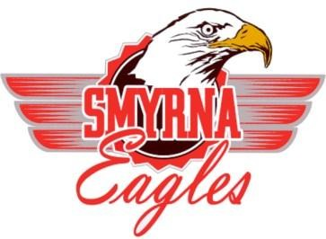
Smyrna High School
Dual Enrollment

Purpose: The purpose of this partnership is to provide high school students in the Smyrna School District with the opportunity to earn either: (a) high school credit and college credit simultaneously or (b) college credit only in the courses provided by the institution they are enrolled in.
Eligibility Requirements:
- Student must be a current member of the senior class.
- Student must rank in the top 50% of their class. (Transfer students must rank in the top 50% of their class at their former high school, as indicated on their transcript)
- Student is registered for the courses necessary for graduation at Smyrna High School.
Dual Enrollment Agreement:
- Smyrna High School students are permitted to enroll for courses at Delaware State University, Delaware Technical & Community College, University of Delaware, Wesley College & Wilmington University provided that the student meets the admission requirements of the college or university.
- It is the students’ responsibility to provide the SHS School Counseling Office with an official copy of the college transcript upon completion of the course. Transcripts must be received no later than two weeks prior to graduation in order for them to be included on the high school transcript and calculated into the GPA.

Letter of Recommendation
This letter is to certify that ___________________________ (DOB__________) will be enrolled in the 12th grade at Smyrna High School. The student currently meets all the requirements set forth by the school and has met with their counselor to review the requirements and agreement.
I have met with the above named student and support their decision to enroll in a college level course. If you have any questions, I may be reached at 302-653-3133.
______________________________ _______________
Tiffany Duke, M.Ed. – Counselor Date

I have met with my student’s counselor and understand the Smyrna High School requirements for dual enrollment.

______________________________ _______________
Parent/ Guardian Date

I have met with my counselor and understand the Smyrna High School requirements for dual enrollment.

______________________________ _______________
Student Date

Principal Approval: _________________________ Date: ____________

